DecidR Prototype Manual
Version: | 1.0
Author(s): | JE
Created: | 01/22/2009
Last modification: | 01/22/2009

Version | Date | Author(s) | Changes
1.0 | 01/22/2009 | JE | Initial version.

Functionality
The Decidr Prototype is a small application with the purpose to send emails over a web service. The aim of developing this prototype was to get knowledge about the technologies, which are needed later for the main project.
The application consists of four major components: the GUI, a BPEL Process (Running on the ODE BPEL engine), an Enterprise Service Bus (Synapse) and the Email web service itself.
The components are linked together as shown in the following picture. The GUI, ODE and Email WS are deployed on a Apache Tomcat server, the ESB (Synapse) is a standalone application. The user input is passed through from the GUI to the email WS and the answer is passed back to the GUI. For detailed information about function and interaction of the components, see the next chapter.

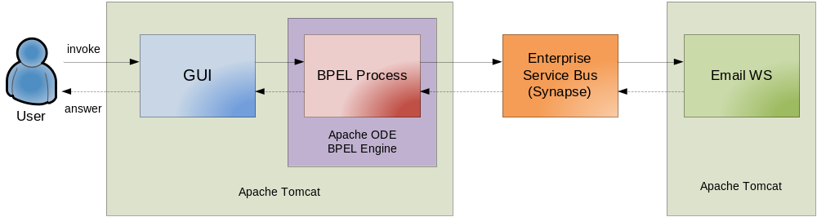

Link to the Tomcat server: http://iaassrv7.informatik.uni-stuttgart.de:8080/
Link to Synapse: http://iaassrv7.informatik.uni-stuttgart.de:8280/

Components

GUI
The GUI is the user entry point of the application. It consists of a simple input form with three fields, “recipient”, “subject” and “message”.
By clicking on the Send button, the GUI invokes the BPEL Process by sending the data to an according web service provided by the ODE BPEL engine. After submit the GUI gives information if the email was successfully sent.
The GUI is located here:
http://iaassrv7.informatik.uni-stuttgart.de:8080/PrototypeUI/

BPEL Process (Running on Apache ODE)
The BPEL Process has one single activity. When it is invoked by the GUI, the email WS on the ESB is called with the passed email contents. The BPEL Process itself is made available over a web service located here:
http://iaassrv7.informatik.uni-stuttgart.de:8080/ode/processes/mailws

Enterprise Service Bus
The task of the Enterprise Service Bus (ESB) here is a simple forwarding of the email data to the email web service. The WSDL provided by the ESB is automatically generated from the email web service WSDL and has exactly the same functionality, so it can be used in the same way as the real web service itself.
The ESB redirection WS is located here:
http://iaassrv7.informatik.uni-stuttgart.de:8280/soap/eMailWS

Email Web Service
The Email web service is a simple web service with the function to send an email to a specific recipient. It contains one operation (“sendEmail”) with parameters “subject”, “message”, “recipient” and “sender”, which contain the needed email data given by the user. The (boolean) return value indicates if the email send operation was successful.
The emails from the web service are sent over a Google Mail account, with the sender address decidr.iaas@googlemail.com. Because the sender address cannot be changed by using this account, the parameter “sender” will be ignored.
Additionally, the Log4J package is implemented to log the processing of the sendEmail function. The data is logged to the logfile of the tomcat server.

The Mail WS is located here:
http://iaassrv7.informatik.uni-stuttgart.de:8080/axis2/services/eMailWS
The WSDL is provided over this link:
http://iaassrv7.informatik.uni-stuttgart.de:8080/axis2/services/eMailWS?wsdl

